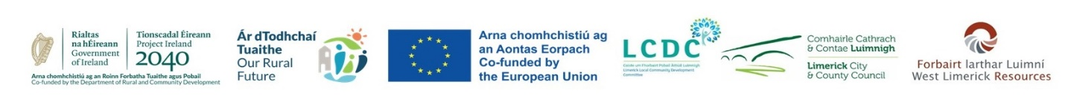

|  |  |  |
| --- | --- | --- |
| **APPLICATION FORM**  **Independent Evaluation Committee**  **LEADER Programme 2023-2027** | | |
| **Personal Details** | | |
| **Name:** |  | |
| **Address:** |  | |
| **Telephone:** |  | |
| **Email:** |  | |
| **Organisation**  **(if relevant)** |  | |
| **Expertise** | | |
| ***Please select your main area of expertise relevant to the* Rural Development (LEADER) Programme** | | ***Please Tick one only*** |
| ***Economic Development (Business)*** | |  |
| ***Financial Analysis*** | |  |
| ***Community/Social Inclusion*** | |  |
| ***Sustainable Development/Environment*** | |  |
| ***Tourism*** | |  |
| ***LEADER Experience*** | |  |
| ***Youth*** | |  |

|  |  |
| --- | --- |
| **Please outline your relevant experience (paid or voluntary) in the area you have chosen.**  ***(Refer to the accompanying documents)***  ***Max 200 words*** |  |
| **Please outline any additional relevant experience / skills / knowledge (paid or voluntary), that would enhance your contribution to the work of the IEC.**  **Max 200 words** |  |
| **Any other information relevant to participation on the IEC which you would like to add**  **Max 150 words** |  |

|  |
| --- |
| **Declaration** |
| Please tick the following   * **I agree that I will be available to attend 6-8 daytime meetings per year, either in person or online** * **I understand that information may be sent to me electronically.** * **I agree to maintain confidentiality and declare any conflicts of interest for the duration of my membership of the IEC** * **I confirm that the details supplied are true and correct to the best of my knowledge.**     **Print Name:** ________________________________  **Signature:** ____________________________________  **Date:** __________/__________________/_________ |

Completed Application Form and any supporting documentation to be returned, either by post to **LEADER Programme Coordinator, West Limerick Resources, St Mary’s Rd., Newcastle West, Co Limerick, or email to srowley@wlr.ie**

**Closing date for Applications is Friday November 22nd 2024.**

**The LCDC reserves the right to seek further clarification on aspects of this form if required.**