MID WEST REGIONAL ILDN ENTERPRISE AWARDS 2019
Application Form
In 2019, the Mid West Regional LDC Enterprise Awards will be presented to persons who have successfully set-up their own business under the Back to Work / Short Term Enterprise Allowance Scheme in the period 2015 - 2018.
If you wish your business to be considered for one of these awards, please complete and return this Application Form in care of the address listed below. Should you require further information please do not hesitate to contact Brenda Heath on 069 62222 or email bheath@wlr.ie
Completed Application Form can be submitted by post to Brenda Heath, Enterprise Officer, West Limerick Resources, St Mary’s Road, Newcastle West, Co Limerick or by email to bheath@wlr.ie no later than 5pm on Wednesday 20th March 2019.

Terms and Conditions Apply:
- You must be a client (current or past) of West Limerick Resources, Enterprise Support Service and of the Back to Work / Short Term / Enterprise Allowance Scheme.
- All applications will be considered by an adjudication panel co-ordinated by the Mid-West Local Development Company (LDC) Enterprise Network. Please note that staff may contact you for more information before consideration by the judges.
- The decision of the judges will be final and binding.
Please verify the following information by ticking the box as appropriate:
I wish to be considered for the Local Development Company Enterprise Award for which I am eligible
I agree to participate in all relevant publicity should I win an award
I am fully tax compliant
I declare that all information provided is true and accurate

Print Name
Signed
Date

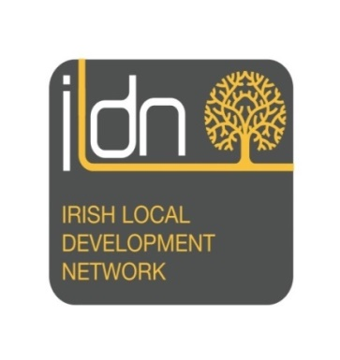
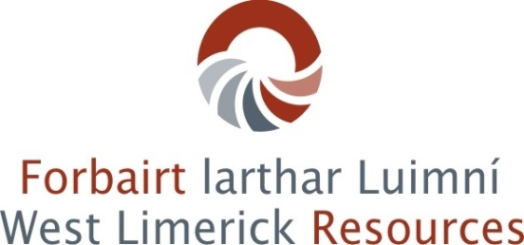
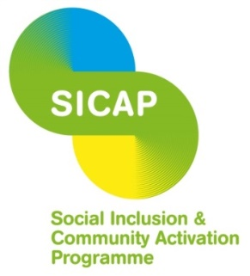

MID WEST REGIONAL ILDN ENTERPRISE AWARDS 2019
Application Form

- Personal Details:
Name of Applicant(s)
Business Name
Address
Tel No.
E-mail

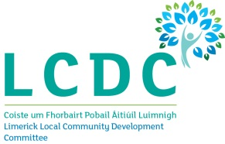
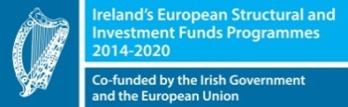
The Social Inclusion and Community Activation Programme (SICAP) 2018-2022 is funded by the Irish Government through the Department of Rural and Community Development and co-funded by the European Social Fund under the Programme for Employability, Inclusion and Learning (PEIL) 2014-2020

2 | Explain your background and previous work experience.  (Tell us about yourself – education, work experience and interests)

3 | Please give a brief description of your business: i.e. Photographer, Repairman, Beautician etc. and the kind of work you normally do

4 | Business Structure (Tick as appropriate)
 | Sole Trader
 | Company
 | Partnership

5 | Start-up date (month/year)

6 | Please give details of the most significant achievement(s) (orders / service contract etc.) of your business since start up

7 | Please state the reason why you and your business should be considered for this award

8 | Please describe, giving examples, the future potential to
a) expand (grow your business)

b) to increase your range of products, services and new business ideas (diversification) of your enterprise

9 | Employment Creation
- Number of Additional Full-time Jobs Created

b) Number of Part-time Jobs Created

c) Potential number of Jobs in total which are likely to be created in next year (including indirect employment)

10 | Briefly explain how BTWEA/STEA Scheme has benefited you

Please provide any additional information supporting your application on a separate page.
Giving examples – Mention challenges you have had in your personal and professional life that you have overcome. Include education to date, training and any IT skills.
Max of 2 typed pages.

